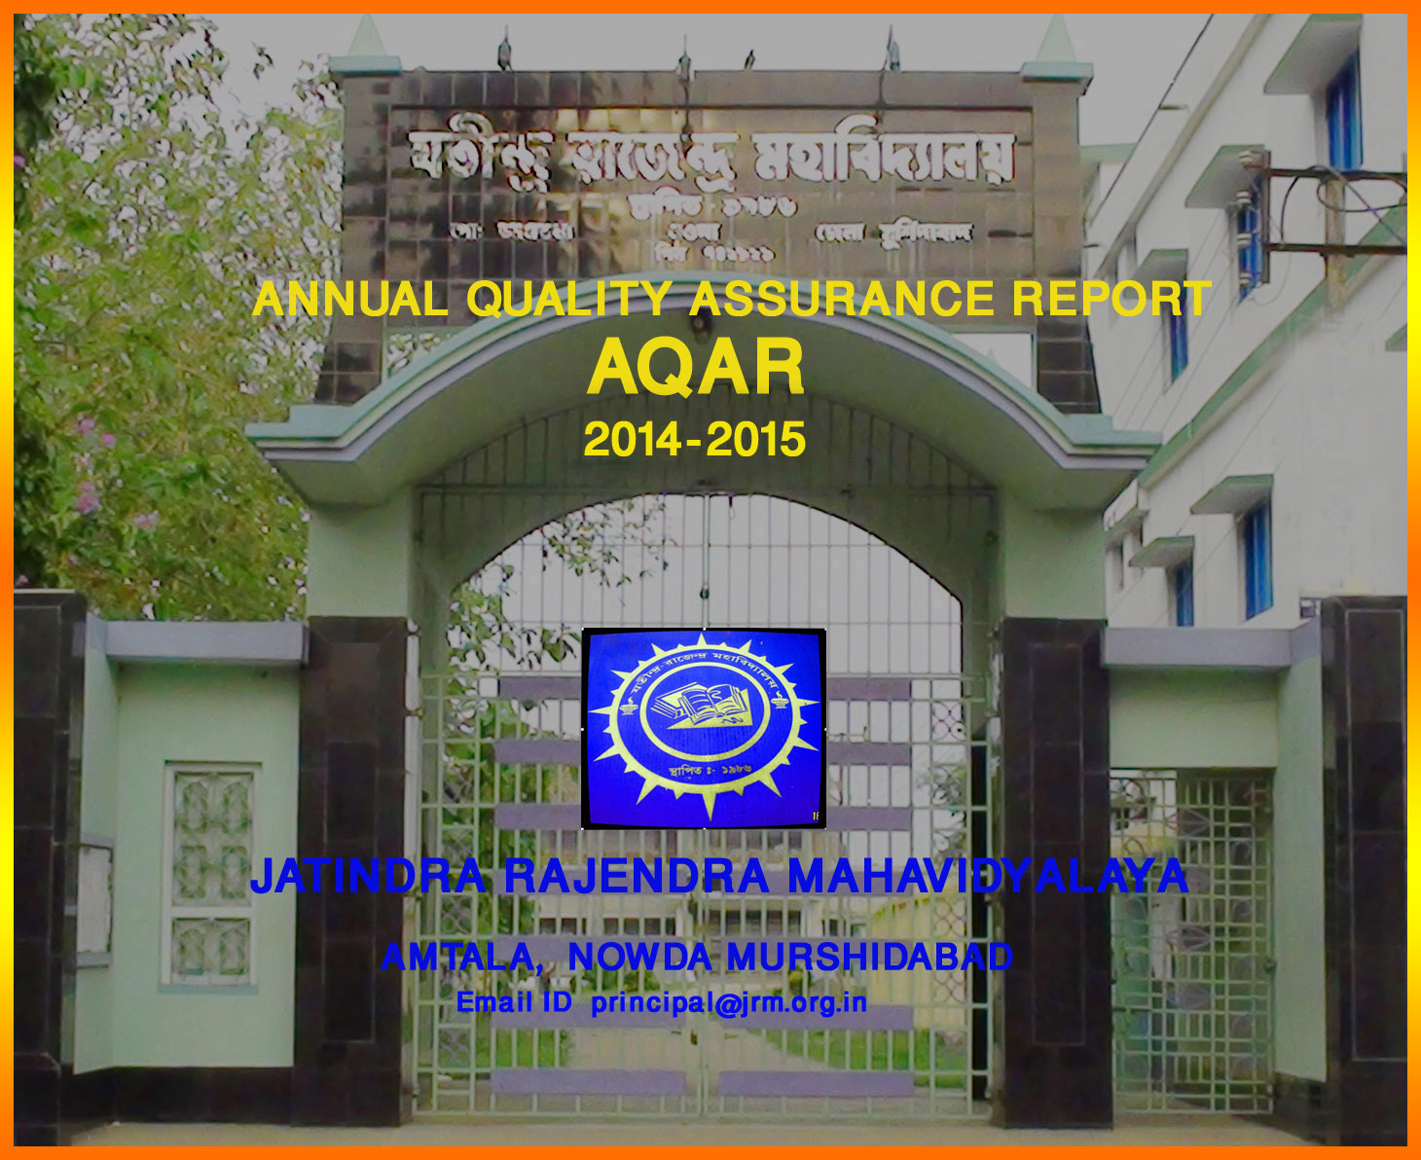

The Annual Quality Assurance Report (AQAR) of the IQAC

All NAAC accredited institutions will submit an annual self-reviewed progress report to NAAC, through its IQAC. The report is to detail the tangible results achieved in key areas, specifically identified by the institutional IQAC at the beginning of the academic year. The AQAR will detail the results of the perspective plan worked out by the IQAC. (Note: The AQAR period would be the Academic Year. For example, July 1, 2012 to June 30, 2013)

Part – A
2014-15
AQAR for the year (for example 2013-14)

1. Details of the Institution
Jatindra Rajendra Mahavidyalaya
1.1 Name of the Institution
P 0 - AMTALA
1.2 Address Line 1
DIST - MURSHIDABAD
Address Line 2
AMTALA
City/Town
WEST BENGAL
State
742121
Pin Code
principal@jrm.org.in

Institution e-mail address
03482 -247244 & 03482 – 247107.
Contact Nos.
GEETALI BERA
Name of the Head of the Institution:

03482 - 247905
Tel. No. with STD Code:
09434687179
Mobile:
SUCHARITA MITRA
Name of the IQAC Co-ordinator:
09732656465
Mobile:
sucharitamitra22@gmail.com
IQAC e-mail address:

WBCOXX13314
1.3 NAAC Track ID (For ex. MHCOGN 18879)
OR

1.4 NAAC Executive Committee No. & Date:
March 31, 2007/241
(For Example EC/32/A&A/143 dated 3-5-2004.
This EC no. is available in the right corner- bottom
of your institution’s Accreditation Certificate)

1.5 Website address:
www.jrm.org.in

Web-link of the AQAR: http:// www.jrm.org.in /AQAR2014-15.doc

1.6 Accreditation Details
Sl. No. | Cycle | Grade | CGPA | Year of Accreditation | Validity Period
1 | 1st Cycle | C++ |  | 2007 | 5
2 | 2nd Cycle
3 | 3rd Cycle
4 | 4th Cycle

1.7 Date of Establishment of IQAC :
29.01.2014

1.8 Details of the previous year’s AQAR submitted to NAAC after the latest Assessment and Accreditation by NAAC ((for example AQAR 2010-11submitted to NAAC on 12-10-2011)
- AQAR 01/12/2015 (DD/MM/YYYY)
- AQAR 04/12/2015 (DD/MM/YYYY)
- AQAR 08/12/2015 (DD/MM/YYYY)
- AQAR 14/12/2015 (DD/MM/YYYY)
1.9 Institutional Status
√

University State Central Deemed Private

Affiliated College Yes No
√

Constituent College Yes No

√

Autonomous college of UGC Yes No

√

√

Regulatory Agency approved Institution Yes No
(eg. AICTE, BCI, MCI, PCI, NCI)
√

Type of Institution Co-education Men Women

√

Urban Rural Tribal

√

√

√

Financial Status Grant-in-aid UGC 2(f) UGC 12B

Grant-in-aid + Self Financing Totally Self-financing

1.10 Type of Faculty/Programme
√

Arts Science Commerce Law PEI (Phys Edu)

TEI (Edu) Engineering Health Science Management

Others (Specify)

1.11 Name of the Affiliating University (for the Colleges)
UNIVERSITY OF KALYANI

1.12 Special status conferred by Central/ State Government-- UGC/CSIR/DST/DBT/ICMR etc: N/A

Autonomy by State/Central Govt. / University

University with Potential for Excellence UGC-CPE

DST Star Scheme UGC-CE

UGC-Special Assistance Programme DST-FIST

UGC-Innovative PG programmes Any other (Specify)

UGC-COP Programmes
2. IQAC Composition and Activities
8
2.1 No. of Teachers
2
2.2 No. of Administrative/Technical staff
0
2.3 No. of students
2.4 No. of Management representatives
Nil
2
2.5 No. of Alumni
2. 6 No. of any other stakeholder and
Nil
community representatives
1
2.7 No. of Employers/ Industrialists
1
2.8 No. of other External Experts
2.9 Total No. of members
14
2.10 No. of IQAC meetings held
3

2.11 No. of meetings with various stakeholders: Faculty
2

1
Non-Teaching Staff Students Alumni Others

2.12 Has IQAC received any funding from UGC during the year? Yes No

√

If yes, mention the amount
2.13 Seminars and Conferences (only quality related) Nil
(i) No. of Seminars/Conferences/ Workshops/Symposia organized by the IQAC

1

5
Total Nos. International National State Institution Level

(ii) Themes

2.14 Significant Activities and contributions made by the IQAC :
The IQAC plans for a range of academic and non-academic activities:
- Online admission software planned to be initiated in the Institution for first year admission.
- Keeping in mind the demand for Arabic honours, the IQAC planned to planned to process the application for it.
- “Safalya Hater Muthoy” planned - a joint initiative of the Institution with ABP Ananda for a grooming workshop for students.
- National seminar on Bengali dram scheduled this year.
- Health awareness seminar planned.
- Anti-dowry day observation, cultural club activities, AIDS Observation Day to be celebrated.
- Wireless amplifier with sound box to be purchased
- Microphone for different announcements within college campus.

2.15 Plan of Action by IQAC/Outcome

The plan of action chalked out by the IQAC in the beginning of the year towards quality
enhancement and the outcome achieved by the end of the year *

Plan of Action | Achievements
The IQAC plans for a range of academic and non-academic activities:  - Online admission software planned to be initiated in the Institution for first year admission.  - Keeping in mind the demand for Arabic honours, the IQAC planned to planned to process the application for it.  - “Safalya Hater Muthoy” - a joint initiative of the Institution with ABP Ananda for a grooming workshop for students planned.  - National seminar on Bengali drama to be done in 14-15  - Health awareness seminar planned.  - Anti-dowry day observation, cultural club activities, AIDS Observation Day planned.  - Wireless amplifier with sound box to be purchased  - Microphone for different announcements within college campus planned. | - Online admission was planned but could not be successfully implemented, will be priority agenda for following session.  - Arabic Honours applied for and all processes completed for implementation in next session.  - “Safalya Hater Muthoy” - a joint initiative of the Institution with ABP Ananda for a grooming workshop for students completed on 11.11.14  - National seminar on Bengali drama in November 2014.  - Health awareness seminar conducted on 21.1.14  - Anti-dowry day observation on 26.11.14, ‘Ma Mujhe Tagore bana de’ – a drama by the cultural club on 19.3.15, AIDS Observation Day celebrated on 3.12.14  - Wireless amplifier with sound box to be purchased  - This was executed successfully and important communications/announcements were done through the use of the microphone.

* Attach the Academic Calendar of the year as Annexure.
2.15 Whether the AQAR was placed in statutory body Yes No

√

√

Management Syndicate Any other body
Provide the details of the action taken
Plan:
The IQAC plans for a range of academic and non-academic activities:
Online admission software planned to be initiated in the Institution for first year admission.
Keeping in mind the demand for Arabic honours, the IQAC planned to planned to process the application for it.
“Safalya Hater Muthoy” - a joint initiative of the Institution with ABP Ananda for a grooming workshop for students planned.
National seminar on Bengali drama to be done in 14-15
Health awareness seminar planned.
Anti-dowry day observation, cultural club activities, AIDS Observation Day planned.
Wireless amplifier with sound box to be purchased.
Microphone for different announcements within college campus planned.
Achievements:
1. Online admission was planned but could not be successfully implemented, will be priority agenda for following session.
_{2.} Arabic Honours applied for and all processes completed for implementation in next session.
_{3.} “Safalya Hater Muthoy” - a joint initiative of the Institution with ABP Ananda for a grooming workshop for students completed on 11.11.14
_{4.} National seminar on Bengali drama in November 2014.
_{5.} Health awareness seminar conducted on 21.1.14
_{6.} Anti-dowry day observation on 26.11.14, ‘Ma Mujhe Tagore bana de’ – a drama by the cultural club on 19.3.15, AIDS Observation Day celebrated on 3.12.14
_{7.} Wireless amplifier with sound box to be purchased
_{8.} This was executed successfully and important communications/announcements were done through the use of the microphone.

Part – B

Criterion – I

1. Curricular Aspects
1.1 Details about Academic Programmes
Level of the Programme | Number of existing Programmes | Number of programmes added during the year | Number of self-financing programmes | Number of value added / Career Oriented programmes
PhD
PG
UG | 12
PG Diploma
Advanced Diploma
Diploma
Certificate
Others
Total | 12

Interdisciplinary
Innovative

1.2 (i) Flexibility of the Curriculum: CBCS/Core/Elective option / Open options
(ii) Pattern of programmes:
Pattern | Number of programmes
Semester
Trimester
Annual | 12

√

1.3 Feedback from stakeholders Alumni Parents Employers Students
(On all aspects)

Mode of feedback : Online Manual Co-operating schools (for PEI)

- The students provided their appraisal of the faculty based on the feedback forms given by the College. This feedback was given to the faculty members, to take active educative steps for teaching improvement.

- Guardians’ feedback was collected through oral communication with them and then appraised for future enhancement of teaching-learning process.

1.4 Whether there is any revision/update of regulation or syllabi, if yes, mention their salient aspects.
N/A

1.5 Any new Department/Centre introduced during the year. If yes, give details.
N/A

Criterion – II
2. Teaching, Learning and Evaluation
2.1 Total No. of permanent faculty
Total | Asst. Professors | Associate Professors | Professors | Others
19 | 7 | 1 |  | 1(CWTT) 10(APTT)

2.2 No. of permanent faculty with Ph.D.
1
2.3 No. of Faculty Positions Recruited (R) and Vacant (V) during the year
Asst. Professors |  | Associate Professors |  | Professors |  | Others |  | Total
R | V | R | V | R | V | R | V | R | V
02 |  |  |  |  |  |  |  | 02

08 -UG
2.4 No. of Guest and Visiting faculty and Temporary faculty

2.5 Faculty participation in conferences and symposia:

No. of Faculty | International level | National level | State level
Attended Seminars/ Workshops |  |  | 05
Presented papers | 4 |  | 01
Resource Persons

2.6 Innovative processes adopted by the institution in Teaching and Learning:

- To enhance classroom teaching-evaluation process self-questioning, interactive discussions between students are encouraged
- Smart-board use in class helps students retain the information shared better.
- Use of Digital Visualizer also piques interest and intellectual stimulation of students.

136
2.7 Total No. of actual teaching days
during this academic year
Students’ often encouraged to evaluated each other’s’ papers in an informal way to reiterate known facts and understand common mistakes.
2.8 Examination/ Evaluation Reforms initiated by
the Institution (for example: Open Book Examination, Bar Coding,
Double Valuation, Photocopy, Online Multiple Choice Questions)

0
1
0
2.9 No. of faculty members involved in curriculum
restructuring / revision / syllabus development
as member of Board of Study/Faculty/Curriculum Development workshop
75%
2.10 Average percentage of attendance of students

2.11 Course/Programme wise
Distribution of pass percentage:

Title of the Programme | Total no. of students appeared | Division
Title of the Programme | Total no. of students appeared | Distinction % | I % | II % | III % | Pass %
B.A.(Hons) | 123 | N/A | 8% | 74% | N/A | N/A
B.A.(Gen) | 71 | N/A | Nil | 8% | N/A | 67%

2.12 How does IQAC/College Administration Contribute/Monitor/Evaluate the Teaching & Learning processes:
IQAC monitors and evaluates the teaching learning process by conducting periodical meetings with faculty
Plans examination schedules, teaching days and holidays.
Promotes training / participation in self- upgradation programmes for teaching faculty.

2.13 Initiatives undertaken towards faculty development Nil
Faculty / Staff Development Programmes | Number of faculty  benefitted
Refresher courses | 1
UGC – Faculty Improvement Programme
HRD programmes
Orientation programmes
Faculty exchange programme
Staff training conducted by the university
Staff training conducted by other institutions
Summer / Winter schools, Workshops, etc.
Others

2.14 Details of Administrative and Technical staff
Category | Number of Permanent  Employees | Number of Vacant  Positions | Number of permanent positions filled during the Year | Number of positions filled temporarily
Administrative Staff | 13 | 02 | 0 | 0
Technical Staff | 1 | 0 | 0 | 0

Criterion – III
3. Research, Consultancy and Extension
3.1 Initiatives of the IQAC in Sensitizing/Promoting Research Climate in the institution

- The Bengali Dept. faculty sent for PhD through FDP scheme was encouraged to share her findings with students and teaching colleagues through a lab to land lecture session.
- The college encourages the teachers to write research papers on different subjects.
- Reprographic facilities/ Internet provided for teachers in Teaching Room.
- Teachers are sanctioned to present papers and participate in seminars.

3.2 Details regarding major projects
 | Completed | Ongoing | Sanctioned | Submitted
Number
Outlay in Rs. Lakhs

3.3 Details regarding minor projects
 | Completed | Ongoing | Sanctioned | Submitted
Number
Outlay in Rs. Lakhs

3.4 Details on research publications
 | International | National | Others
Peer Review Journals
Non-Peer Review Journals
e-Journals
Conference proceedings

3.5 Details on Impact factor of publications:

Range Average h-index Nos. in SCOPUS
3.6 Research funds sanctioned and received from various funding agencies, industry and other organisations
Nature of the Project | Duration  Year | Name of the  funding Agency | Total grant  sanctioned | Received
Major projects
Minor Projects
Interdisciplinary Projects
Industry sponsored
Projects sponsored by the University/ College
Students research projects
(other than compulsory by the University)
Any other(Specify)
Total

3.7 No. of books published i) With ISBN No. Chapters in Edited Books

ii) Without ISBN No.
3.8 No. of University Departments receiving funds from
UGC-SAP CAS DST-FIST

DPE DBT Scheme/funds
3.9 For colleges Autonomy CPE DBT Star Scheme

INSPIRE CE Any Other (specify)

N/A
3.10 Revenue generated through consultancy
Level | International | National | State | University | College
Number
Sponsoring agencies
3.11 No. of conferences
organized by the Institution: Nil
Nil
3.12 No. of faculty served as experts, chairpersons or resource persons

3.13 No. of collaborations: N/A International National Any other
Nil
3.14 No. of linkages created during this year
3.15 Total budget for research for current year in lakhs : Nil

From Funding agency From Management of University/College
Total

3.16 No. of patents received this year: N/A
Type of Patent |  | Number
National | Applied
National | Granted
International | Applied
International | Granted
Commercialised | Applied
Commercialised | Granted

3.17 No. of research awards/ recognitions received by faculty and research fellows
Of the institute in the year: N/A
Total | International | National | State | University | Dist | College

3.18 No. of faculty from the Institution
Nil
who are Ph. D. Guides
and students registered under them
Nil

3.19 No. of Ph.D. awarded by faculty from the Institution
Nil

3.20 No. of Research scholars receiving the Fellowships (Newly enrolled + existing ones): N/A

JRF SRF Project Fellows Any other

3.21 No. of students Participated in NSS events:
2
0
University level State level
National level International level
0
0

3.22 No. of students participated in NCC events: N/A

University level State level
National level International level

3.23 No. of Awards won in NSS:
0
University level State level
0
National level International level
0
0

3.24 No. of Awards won in NCC: N/A
University level State level

National level International level

3.25 No. of Extension activities organized

University forum College forum

4

NCC NSS Any other

3.26 Major Activities during the year in the sphere of extension activities and Institutional Social Responsibility

The importance of afforestation and need for tree plantation was stressed through a
programme organised by the NSS cell of the Institution.
Stress was given on the education of the girl child by observation of ‘International Women’s Day’. A programme on “Motherhood and Child Care” was arranged to spread awareness about this issue among students and localites.
The importance of primary school education for a good foundation to one’s future life was stressed upon.

Criterion – IV
4. Infrastructure and Learning Resources
4.1 Details of increase in infrastructure facilities:
Facilities | Existing | Newly created | Source of Fund | Total
Campus area | 1505.56 sq m. | 0 |  | 1505.56 sq m.
Class rooms | 16 | 3 | College Fund | 19
Laboratories | 0 | 0 |  | 0

Seminar Halls | 0 | 0 | 0 | 0
No. of important equipments purchased (≥ 1-0 lakh) during the current year. | 36 | 42 | Merged Scheme UGC  College Fund | 78
Value of the equipment purchased during the year (Rs. in Lakhs) including Others |  | 2,14450 | UGC & College Grant | 2,14450

4.2 Computerization of administration and library
The office was adequately stocked with modern gadgets and digitalisation was completed in the administrative process.
The library books lending and receiving was inventoried digitally.

4.3 Library services:
 | Existing |  | Newly added |  | Total
 | No. | Value | No. | Value | No. | Value
Text Books,  Reference Books,  e-Books,  Journals,  e-Journals,  Digital Database,  CD & Video,  Others (specify) | 19195 | 1388834 | 354 | 34651 | 19549 | 1423485

4.4 Technology up gradation (overall)
 | Total Computers/Laptops | Computer Labs | Internet | Browsing Centres | Computer Centres | Office | Depart-ments | Others
Existing | 36 | Nil | 10 | Nil | Nil | 12 | 0 | 04
Added | 2 | Nil | 0 | Nil | Nil | 2 | 0 | 0
Total | 38 | Nil | 10 | Nil | Nil | 14 | 0 | 04

4.5 Computer, Internet access, training to teachers and students and any other programme for technology
upgradation (Networking, e-Governance etc.)
Technical knowledge of computer usage and how to maximise the extraction of specific information from it was given periodically by local trained personnel.

4.6 Amount spent on maintenance :
127859/-
i) ICT
89323/-
ii) Campus Infrastructure and equipment
229999/-
iii) Others

Total :
447181/-

Criterion – V
5. Student Support and Progression
5.1 Contribution of IQAC/ College Administration in enhancing awareness about Student Support Services
- There is an orientation class to inform students about the support services.
- Close circuit cameras (CCTV) have been mounted at vantage points in the campus to survey the students’ activities, especially prevent/protect girl students from any undesirable situations.
- Health of the students is a matter of great concern for the college administration. Health Awareness programmes help focus on various issues of students, especially stress-related disorders as well as gynaecological problems of girl-students.
- Use of Smart-board and Digital Visualizer made classes interesting and very informative. DVDs were shown in certain periods to reiterate interest of topics taught in class.
- Anti-Dowry day was celebrated to bring to the fore the burning issue of dowry deaths especially in a backward area like that of our college neighbourhood where dowry deaths make headlines even in 2015.
- Rally for Environmental Consciousness was organised by the IQAC.
- Different seminars on various subjects were organised to make students aware of current thoughts and theories.

5.2 Efforts made by the institution for tracking the progression
- Continuous evaluation through unit tests, sessional examinations, home assignments.
- Intra-departmental discussions are arranged between teachers and students for first-hand assessment of knowledge acquired.
- Involvement of students in various programmes such as quiz, debate and other such competitions.

5.3 (a) Total Number of students
UG | PG | Ph. D. | Others
1874

(b) No. of students outside the state
Nil
Nil
(c) No. of international students

No | %
914 | 49
Men Women
No | %
960 | 51
Last Year |  |  |  |  |  | This Year
General | SC | ST | OBC | Physically Challenged | Total | General | SC | ST | OBC | Physically Challenged | Total
1846 | 113 | 03 | 95 | 02 | 2059 | 1707 | 83 | 01 | 70 | 13 | 1874
Demand ratio 1: 1.56 Dropout 27% (Mid-Term)
5.4 Details of student support mechanism for coaching for competitive examinations (If any)

Interested students informally clear doubts and queries through discussions with teachers. Also books on various competitive exams and preparations are available in the library.

No. of students beneficiaries
0

5.5 No. of students qualified in these examinations : Nil

NET SET/SLET GATE CAT
IAS/IPS etc State PSC UPSC Others

5.6 Details of student counselling and career guidance
Nil

Nil
No. of students benefitted

5.7 Details of campus placement: N/A
On campus |  |  | Off Campus
Number of Organizations Visited | Number of Students Participated | Number of Students Placed | Number of Students Placed

5.8 Details of gender sensitization programmes

- Special programmes on sensitizing the students on the importance of mother and child care conducted by the college with the help of NSS unit.
- International Women’s Day was celebrated in college to commemorate the strength and significance of women in society.
- Anti-Dowry Day observed and eminent speakers brought in to highlight this burning issue.

5.9 Students Activities
5.9.1 No. of students participated in Sports, Games and other events
2

State/ University level National level International level

No. of students participated in cultural events

State/ University level National level International level

5.9.2 No. of medals /awards won by students in Sports, Games and other events: Nil

Sports : State/ University level National level International level

Cultural: State/ University level National level International level

5.10 Scholarships and Financial Support
 | Number of  students | Amount
- Financial support from institution | 102 | 16000
- Financial support from government | 568 | 1200000
- Financial support from other sources | Nil | Nil
Number of students who received International/ National recognitions | Nil | Nil

- We provide financial support to our Student’s Welfare Fund.
- Financial Support from Government Includes Minority Scholarship, West Bengal Merit-cum-Means Scholarship of BPL students, and scholarships to wards of bidi workers
- Sitaram Jindal Foundation Scholarship

5.11 Student organised / initiatives
0
0
0
Fairs : State/ University level National level International level
0
0
0
Exhibition: State/ University level National level International level
4
5.12 No. of social initiatives undertaken by the students

5.13 Major grievances of students (if any) redressed:
- Students have difficulty following English lectures so bilingual lectures were arranged even in English Honours classes to help them understand the subject matter.
- Spoken English class was in high demand, therefore a beginners’ course to help transition from ignorance to light was created, called SETU.

Criterion – VI
6. Governance, Leadership and Management
6.1 State the Vision and Mission of the institution
VISION:
Our Mahavidyalaya, ensconced in the natural surroundings of the rural area of Murshidabad, is a beacon of hope for students of this financially backward belt, with a hunger for knowledge and growth. Our vision is to respond to the changing social realities of this region and empower the next generations of learners with values of dignity, equality, social justice and human rights for all. There is special emphasis on the higher education of the female population, mostly from the minority community, to help them voice their struggles and aspirations.
MISSION
- It is a challenge to initiate the need and hunger for education in unlearned masses in these rural areas. We strive to better ourselves in every sphere to provide improved and easy access to knowledge for the backward population of our region.
- Female education and self-awareness is of paramount importance as majority of women in this area is uneducated and suffering from various superstitions which impede their progressive thinking. The importance of this institution in this remote neighbourhood is evidenced by the fact that almost 50% students are female students and specifically from the minority community.
- In keeping with the agricultural way of life, students are to be initiated into scientific modes of thinking. Thus an attempt is made to amalgamate the two for an improved lifestyle, at the same time restrict brain-drain from this rural sector so that more educated youth -generations strive to remain here and not get sucked up into the fascination of going towards the urban way of life.

6.2 Does the Institution has a management Information System

N/A

6.3 Quality improvement strategies adopted by the institution for each of the following:
6.3.1 Curriculum Development
The curriculum provided by the Kalyani University is adhered to while teaching in class. However, teachers are encouraged to update themselves with latest theories on areas of the curriculum by bringing accessory reference material for meritorious students to access last information in the class itself.
Also, weaker students are focused upon by making areas of study easier with special notes made by teachers in individual departments.

6.3.2 Teaching and Learning

- Use of device like Digital Visualizer, Smart board helped teaching curriculum topics with greater depth and emphasis.
- Students expanded their own study material with internet-based knowledge through provision of computers in the college.

6.3.3 Examination and Evaluation
- Attendance in college was taken as a major condition for Evaluation.
- Objective-type tests, open- book assessment, periodical exams were regular means of evaluation for students
- Provision of college teachers as examiners, paper-setters, scrutineers, head-examiners, moderators in University examinations.

6.3.4 Research and Development

- Encourage teachers to commence research, publish papers/articles for self-upgradation.
- Facilitate teachers with study leave for research project/submission of PhD thesis.

.3.5 Library, ICT and physical infrastructure / instrumentation
- Text- books, reference material available for students in the library.
- With digitalization of library, efforts were on to provide continuous internet connection for uninterrupted reading for students.
- Reading Room furnished with adequate benches for comfortable reading.
- Since many students in the college come from poor families, use of Xerox machine for photocopies of text/reference books are provided free of cost to the needy students.

6.3.6 Human Resource Management

    - Human Resource Management
- Faculties were provided opportunities to engage in Research and Faculty Development programmes.
- Due to interest in cultural activities, the students were provided opportunity to participate in programmes of the Cultural Club established for them within the academic session. Bengali Drama was organised. Cultural show like “Maa Mujhe Tagore Bana De” was staged for students.
- Teachers in subjects were recruited as per recommendations of College Service Commission following proper rules and regulations.

6.3.7 Faculty and Staff recruitment
- Faculty and staff are recruited as per Govt. norms/rules.
- Non-teaching staff are recruited transparently by college authorities as per Governing Body rules.
- Faculty recruited by College Service Commission. Contractual and Part-Time Teachers are recruited by an expert committee which includes a University expert.

6.3.8 Industry Interaction / Collaboration
Nil

6.3.9 Admission of Students
- The admission committee is in charge of the admission process.
- Admission is strictly on basis of merit.
- All rules and regulations, seat reservation policy of affiliated University and government are maintained.
- The college provides information about details of admission process and relevant dates, fee structure, student support on the notice board.
- A detailed admission prospectus is also available to all students.
- Online admission was planned but could not be put in place due lac of expertise and infrastructure this year.

6.4 Welfare schemes for
Teaching | - Advance Payment against Salary.  - Co-operative Fund.  - Canteen Facilities.
Non teaching | - Advance payment against salary  - Puja/Eid bonus for Casual staff.  - Group Insurance and Co-operative Fund.
Students | - Poor student aid Fund  - Students’ Health Home  - Tuition-waiver/ Free Studentship  - Admission fees in instalments.

Nil
6.5 Total corpus fund generated

√

6.6 Whether annual financial audit has been done Yes No

6.7 Whether Academic and Administrative Audit (AAA) has been done?
Audit Type | External |  | Internal
Audit Type | Yes/No | Agency | Yes/No | Authority
Academic | No | N/A | No | N/A
Administrative | No | N/A | No | N/A

6.8 Does the University/ Autonomous College declare results within 30 days?

√

For UG Programmes Yes No

For PG Programmes Yes No

6.9 What efforts are made by the University/ Autonomous College for Examination Reforms?
N/A

6.10 What efforts are made by the University to promote autonomy in the affiliated/constituent colleges?
N/A

6.11 Activities and support from the Alumni Association
There is no established alumni association of the college. However, alumni support at informal level is there to help students at different times.

6.12 Activities and support from the Parent – Teacher Association
There is no formal Parent-Teacher Association. However, on significant occasions, parents are invited to help/participate in various activities.

6.13 Development programmes for support staff
- Pay-related issues of staff- members monitored by college administration through NTS Council
- Festival bonus given to support staff
- Advance payment against Salary to help during times of personal emergency
- Loan facilitated in times of financial need from Staff Cooperative Fund

6.14 Initiatives taken by the institution to make the campus eco-friendly
- Continuation of the drive to keep college campus plastic-free and no-smoking zone.
- Use of mobile phones by the students in the college banned
- Create consciousness about environment through classroom teaching and practical lessons like rallies by students of ENVS Studies
- Involvement of students in campus maintenance and beautification

Criterion – VII
7. Innovations and Best Practices
Academic Initiatives of the College:
- Question Bank of Model Questions constructed by individual departments to help students practise for Board Exams.
- Classroom teaching upgraded with use of devices like the Digital Visualizer and Smart Board.
Green Initiative of the College:
- The college has one eco-club which conduct activities relating to Environment Consciousness in the college campus.
- To observe Briksha Ropan as a culture and not a mere event only creating awareness among students to preserve environment
- To replicate the practice of “Gandhi Punnahya” [Gandhiji introduced the practice of cleaning the Ashrama in Santiniketan (the workplace of Rabindranath Tagore)] by members of the ashrama]
- The use of plastic bags is avoided in the campus
- Use of efficient lighting arrangements, LED or CFL instead of normal lights
- Making students and staffs aware regarding the judicious use of electricity and water
- Storing the wastes separately in Storage Bins and not allowing the same to be dumped in Dump-yard etc.
Gender Sensitisation:
- ‘Mother and Child Care’ programme helps spread cognizance about issues of female and child mental and physical well-being.
- College administration is responsive to any complaints or grievances of the female students with regard to sexual harassment.
Administrative Initiatives of the college:
- An online notification system has been developed through the SMS gateway enabling the college authority to reach out to the students to share important notifications and information

7.1 Innovations introduced during this academic year which have created a positive impact on the
functioning of the institution. Give details.

7.2 Provide the Action Taken Report (ATR) based on the plan of action decided upon at the
beginning of the year

1. Online admission was planned but could not be successfully implemented, will be priority agenda for following session.
2. Arabic Honours applied for and all processes completed for implementation in next session.
3. “Safalya Hater Muthoy” - a joint initiative of the Institution with ABP Ananda for a grooming workshop for students completed on 11.11.14
4. National seminar on Bengali drama in November 2014.
5. Health awareness seminar conducted on 21.1.14
6. Anti-dowry day observation on 26.11.14, ‘Ma Mujhe Tagore bana de’ – a drama by the cultural club on 19.3.15, AIDS Observation Day celebrated on 3.12.14
7. Wireless amplifier with sound box to be purchased
8. This was executed successfully and important communications/announcements were done through the use of the microphone.

7.3 Give two Best Practices of the institution (please see the format in the NAAC Self-study Manuals)
Title of the Practice – “Sachetan Mon” (Conscious Mind)

Objectives of the Practice
Building conscious mind towards empowering students

The Context
It is well appreciated by the college authority that one inch of consciousness amongst the students - particular so in a region where women students from minority sect are present in significant numbers - will lead to miles of societal consciousness
The Practice
Observing regular programmes on consciousness building on sensitizing issues like environment concerns, dowry movement, communal disharmony, girl child deaths etc.
Problems Encountered and Resources Required
Problem – Initial hesitancy and lack of enthusiasm
Monetary Resource – Fund constraint
Evidence of success
During the last four years altogether 13 programmes are held wherein 17 resource persons have spoken to the hundreds of rural students leading to building of Sachetan Mon

Title of the Practice – “Setu” (The Bridge)

Objectives of the Practice
The Department of English off-late has introduced a bridge course on Learning English to learn English better
The Context
The demand ratio for admission in English Honours is commendably high
Students taking admission in English Honours is holds good academic records (Max 76% Min 60%)
But their basic English language literacy level is much below the standards necessary for learning English literature

The Practice
Towards enhancement of the English language literacy level the college adopts the best practices
Phase 1 - Conducting need assessment
Phase 2 - Designing curriculum
Phase 3 - Delivery of the curriculum beyond class hours
Problems Encountered and Resources Required
Problem – No problem encountered
Evidence of success
Not much success is yet visible as the practice is too young

7.4 Contribution to environmental awareness / protection
• The college has one eco-club which conduct activities relating to Environment Consciousness in the college campus.
• To observe Briksha Ropan as a culture and not a mere event only creating awareness among students to preserve environment
• To replicate the practice of “Gandhi Punnahya” [Gandhiji introduced the practice of cleaning the Ashrama in Santiniketan (the workplace of Rabindranath Tagore)] by members of the ashrama]
• The use of plastic bags is avoided in the campus
• Use of efficient lighting arrangements, LED or CFL instead of normal lights
• Making students and staffs aware regarding the judicious use of electricity and water
• Storing the wastes separately in Storage Bins and not allowing the same to be dumped in Dump-yard etc.

7.5 Whether environmental audit was conducted? Yes No

7.6 Any other relevant information the institution wishes to add. (for example SWOT Analysis)

8. Plans of institution for next year
- Online admission to be processed successfully.
- Feedback software to be put in place.
- More and regular use of ICT in teaching learning process.
- To increase the scope of Setu- the Bridge programme to include more students.

Name SUCHARITA MITRA Name GEETALI BERA
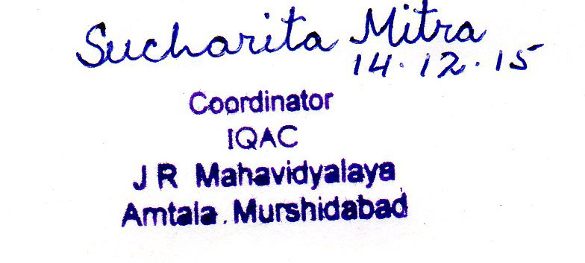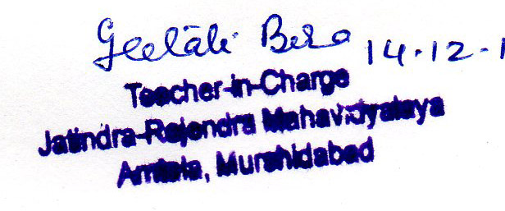
_____________________________ _______________________________
Signature of the Coordinator, IQAC Signature of the Chairperson, IQAC

_______***_______

Annexure I
Abbreviations:
CAS - Career Advanced Scheme
CAT - Common Admission Test
CBCS - Choice Based Credit System
CE - Centre for Excellence
COP - Career Oriented Programme
CPE - College with Potential for Excellence
DPE - Department with Potential for Excellence
GATE - Graduate Aptitude Test
NET - National Eligibility Test
PEI - Physical Education Institution
SAP - Special Assistance Programme
SF - Self Financing
SLET - State Level Eligibility Test
TEI - Teacher Education Institution
UPE - University with Potential Excellence
UPSC - Union Public Service Commission

ANNEXURE 1
JATINDRA RAJENDRA MAHAVIDYALAYA
ESTD – 1986
P.O- Amtala, Dist – Murshidabad Pin Code – 742121
ACADEMIC CALENDER 2014-2015
Month | Teaching days | Commencement of Classes | Exam days | Scheduled breaks & other activities
JULY | 05 | - | - | Id- ul fitre
AUGUST | Nil |  | University Exams | Independence Day, Janmashtami.
SEPTEMBER | 16 | Ist, 2nd & 3rd year classes | Nil | Students Registration for Part I Students, Freshers Welcome & College social function, Mahalaya, Puja Vacation
OCTOBER | 05 | - | Nil | Puja Vacation continues,Gandhi Jayanti.
NOVEMBER | 20 | - | Nil | Muharram, Guru Nanak Jayanti, Annual Sports, National Level Seminar.
DECEMBER | 15 | - | Nil | College Foundation Day, College social function, Winter Recess.
JANUARY | 15 | - | Test Exams (Part III) | Netaji Jayanti, Republic Day, Saraswati Puja, Vivekananda’s Birthday
FEBRUARY | 17 | - | Test Exams (Part II) | -
MARCH | 20 | - | - | Holi
APRIL | 23 | - | - | Bengali New Year, Ambedkar Jayanti, Good Friday
MAY | NIL | - | Test Exams (Part I) | May Day, Rabindra Jayanti
JUNE | Nil | - | - Test Exams (Part I) | -

